TYPE THE TITLE OF YOUR PAPER HERE WITH CAPITAL LETTERS

Name Surname ¹, Name Surname ², Name Surname ³, …
¹ Author’s full postal address of affiliation including the country name
² Author’s full postal address of affiliation including the country name
³ Author’s full postal address of affiliation including the country name

Corresponding author:
Name Surname, email@adress.xx
ABSTRACT
Prepare your abstract in this file. 2 pages concise and factual abstract is required. Second page can be JPG poster in good quality. The abstract should include the purpose of research, principal results and major conclusions. References should be avoided, if it is essential, only cite the author(s) and year(s) without giving reference list.
Keywords: climate change, climate indicators, climate variability

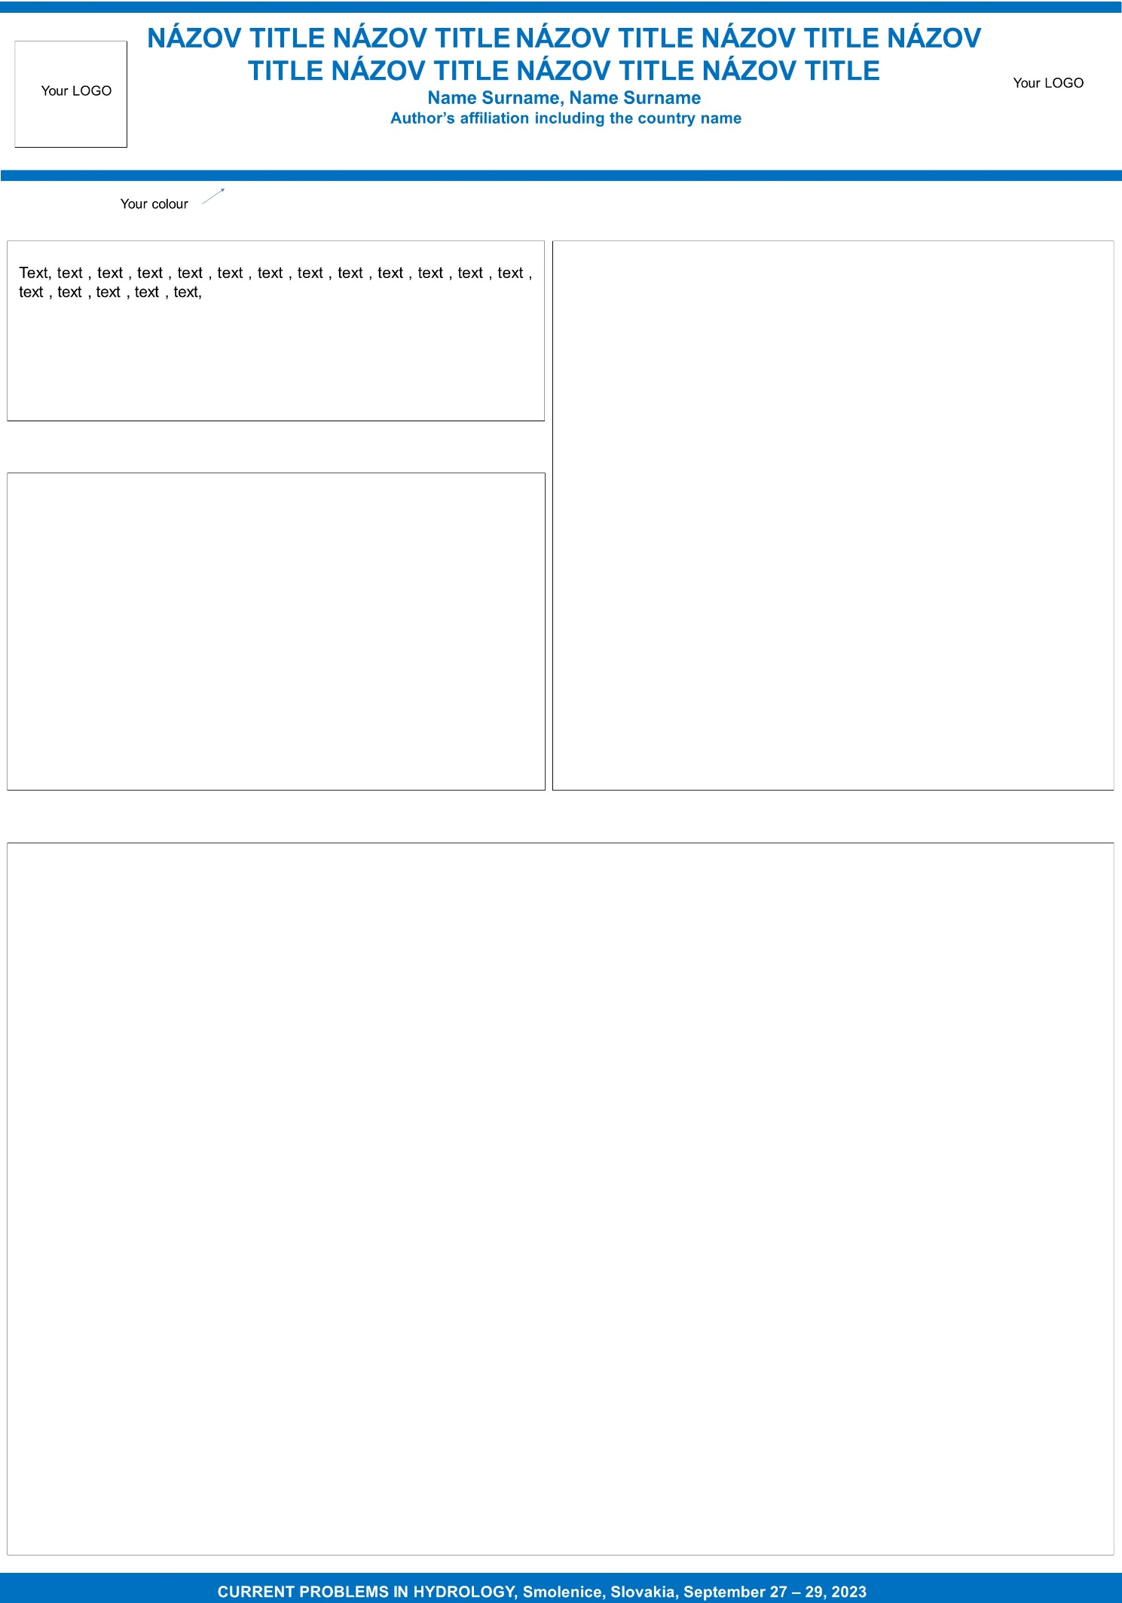
Nevymazať, not delete this page

